TEMPLECITY INSTITUTE OF TECHNOLOGY & ENGINEERING
BARUNEI, KHURDA.
DIPLOMA
1st Internal Examination– 2022

(3rd semester, Branch-Mechanical), Sub-EM
Full Marks: 20 Times: 1 Hour

(3*2)
- Answer all the questions.
a) Give the classifications of steels.
b) Describe the properties and typical applications of low medium, and high- carbon steels.
c) What is an alloy steel? How are alloy steels classified? Explain them.

- Answer any two. (2*3.5)

a) Write down the composition, properties and applications of the following metals. (1)Grey cast iron (2) white cast iron (3) nodular cast iron (4) malleable cast iron

b) Write short notes on Particle reinforced composites and fiber reinforced composites.

c) Explain the heat treatment process of steel.

3. Answer any one. (1*7)
a) Explain Iron-Carbon Phase Diagram.
b) What Are The Micro-Constituents Of Iron- Carbon Alloys? Explain The General Characteristic Of Each.

ANSWERS

Q1) A)
According to the American Iron & Steel Institute (AISI), steel can be categorized into four basic groups based on the chemical compositions:
1. Carbon steel
2. Alloy steel
3. Stainless steel
4. Tool steel

Properties:
Low-carbon steel is the most widely used form of carbon steel. These steels usually have a carbon content of less than 0.25 wt.%. They cannot be hardened by heat treatment (to form martensite) so this is usually achieved by cold work.
Medium-carbon steel has a carbon content of 0.25 – 0.60 wt.% and a manganese content of 0.60 – 1.65 wt.%. The mechanical properties of this steel are improved via heat treatment involving autenitising followed by quenching and tempering, giving them a martensitic microstructure.
High-carbon steel has a carbon content of 0.60– 1.25 wt.% and a manganese content of 0.30 – 0.90 wt.%. It has the highest hardness and toughness of the carbon steels and the lowest ductility. High-carbon steels are very wear-resistant as a result of the fact that they are almost always hardened and tempered.
Applications

Low-carbon steel
Low carbon steels are often used in automobile body components, structural shapes (I-beams, channel and angle iron), pipes, construction and bridge components, and food cans.

Medium-carbon steel
As a result of their high strength, resistance to wear and toughness, medium-carbon steels are often used for railway tracks, train wheels, crankshafts, and gears and machinery parts requiring this combination of properties.

High-carbon steel
Due to their high wear-resistance and hardness, high-carbon steels are used in cutting tools, springs high strength wire and dies.
C)
Alloy steel is a type of steel that has undergone alloying using different elements in levels between 1% and 50% in weight in order to enhance mechanical properties. It can be classified further into two types: high-alloy and low-alloy steels.

Q2) I)
Grey cast iron, or gray iron, has a dark grey fracture colour due to a graphitic microstructure. The presence of graphite flakes is due to the addition of silicon, which acts to stabilise carbon in the form of graphite as opposed to iron carbide. Grey cast iron typically has a composition of 2.5 wt.% – 4.0 wt.% carbon and 1.0 wt.% – 3.0 wt.% silicon.
APPLICATION
Grey cast iron is the most common form of cast iron. It is used in applications where its high stiffness, machinability, vibration dampening, high heat capacity and high thermal conductivity are of advantage, such as internal combustion engine cylinder blocks, flywheels, gearbox cases, manifolds, disk brake rotors and cookware.
II)
White CIs are hard and brittle and cannot be machined easily. White CI is the only member of the CI family in which carbon is present only as carbides. Because of the absence of graphite, it has a light appearance. The presence of different carbides makes white CIs extremely hard and abrasion resistant, but also very brittle. The microstructure of white CI contains massive cementite (white) and pearlite. White cast iron derives its name from the white, crystalline crack surface observed when a casting fractures. Most white cast irons contain less than 4.3% carbon, with low silicon contents to inhibit the precipitation of carbon as graphite. It is used in applications where abrasion resistance is important and ductility not required, such as liners for cement mixers, ball mills, certain types of drawing dies and extrusion nozzles. White cast iron is generally considered unweldable. The absence of any ductility that can accommodate welding-induced stresses in the base metal and heat affected zone adjacent to the weld results in cracking during cooling after welding.
III) The range of the chemical composition for the nodular cast iron with carbides and a mixture of upper and lower bainite was as follows (wt %): C=3.57–3.83 %, Si = 2.36–2.87 %, Mn 0.05–0.09 %, Cr=0.00–0.34 %, Mo = 1.91–2.05 %, and Ni=1.33–1.62 %.
Nodular Cast Iron is an engineering material displaying high ductility, elastic modulus, mechanical strength and corrosion resistance; in addition, it has low cost and is easy to produce and machine and is thus widely used as a structural material.
Q2B)
Particle reinforced composite:
Particles are made from metal powder, mineral powder, ceramic powder & carbon black. Particles increases elasticity modulus & decreases ductility & permeability. It also produces inexpensive composite material.
i) Large particle composite: Its features are as follows
- Particulate phase is harder & stiffer than matrix phase.
- There is restriction of movement of matrix phase surrounding the dispersed phase.
- Matrix phase transfer some of the applied stress to the particles.
- The strength of bonding between matrix phase & dispersed phase at the interface decides the mechanical properties.
Fiber-reinforced composite:
A fiber-reinforced composite (FRC) is a composite building material that consists of three components:
- the fibers as the discontinuous or dispersed phase,
- the matrix as the continuous phase, and
- the fine interphase region, also known as the interface.
This is a type of advanced composite group, which makes use of rice husk, rice hull,rice shell, and plastic as ingredients. This technology involves a method of refining, blending, and compounding natural fibers from cellulosic waste streams to form a high-strength fiber composite material in a polymer matrix. The designated waste or base raw materials used in this instance are those of waste thermoplastics and various categories of cellulosic waste including rice husk and saw dust.

Q2C) Heat Treatment Process of Steel
  - Annealing
The process consists of slow heating the steel slightly above (30-50ºC) the critical point (AC3) for hypo eutectoid (GS) and the same amount above PSK for the hyper eutectoid holding it at this temp for considerable period (3.4 min/mm length of piece); slow cooling in sand (the rate of cooling from 30ºC to 200ºC depends upon the composition of the steel. The grain structure has coarse Pearlite with ferrite or Cementite (depending on whether hypo or hyper eutectoid). The steel becomes soft and ductile.
Austenite - Pearlite and Ferrite (Hypo eutectoid)
- Pearlite (Eutectoid)
- Pearlite + Cementite (Hyper eutectoid)
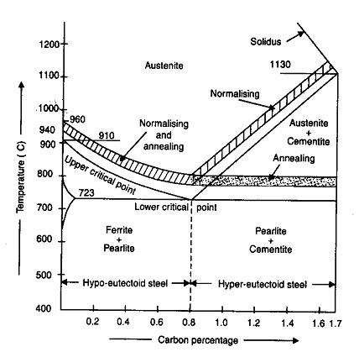
The purpose of annealing may involve one or more of the following aims:
- To soften the steel and to improve machinability.
- To relieve internal stresses induced by some previous treatment (rolling, forging, uneven cooling).
- To remove coarseness of grain.
- To refine the grain size and structure to improve strength and ductility.
- To alter electrical and magnetic properties.
  - Normalizing
It consists of heating the metal to a temperature just above the critical point (40-50ºC) above AC3 line GS and ACm (GSE) within the normalizing range, holding it at this temp for period of 15 min and cooling in still air to room temperature. This process provides a homogeneous structure consisting of ferrite and pearlite for hypo eutectoid steels and pearlite and cementite for hyper eutectoid steels. This is done,
- To produce a harder and stronger steel than full annealing
- To refine the grain structure of steel to improve the machinability and tensile strength.
- To modify and refine the grain structure
- To obtain a relatively good ductility without reducing the hardness and strength
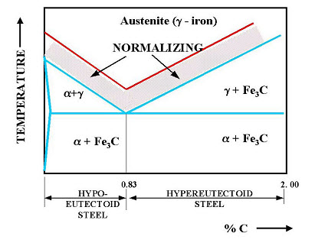
Hardness is a function of the carbon content of the steel. Hardening of a steel requires a change in structure from the body-centered cubic structure found at room temperature to the face-centered cubic structure found in the austenitic region. The steel is heated to autenitic region. When suddenly quenched, the martensite is formed. This is a very strong and brittle structure. When slowly quenched it would form austenite and pearlite which is a partly hard and partly soft structure. When the cooling rate is extremely slow then it would be mostly pearlite which is extremely soft.
III) Hardening
It consists of heating the steel to a temperature above the critical point (30-50ºC) above AC3 line; holding it at this temperature for a considerable period; quenching (sudden cooling) in water, oil/molten salt solution. The heating operation is required form the purpose of transforming the ferrite and pearlite for hypo eutectoid steels and pearlite and cementite for hyper eutectoid steels into austenite. A rapid cooling form the hardened temperature causes austenite to be transformed into martensite which is very hard and brittle.
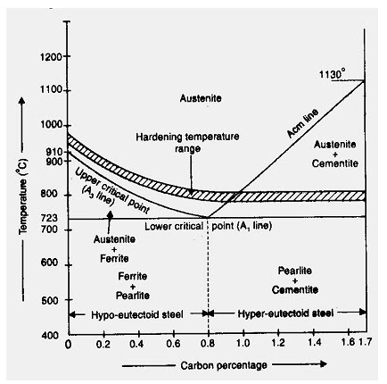
Fig.4.1.4. Hardening process
This is done to develop hardness to resist wear and to improve strength, elasticity, ductility and toughness and to enable it to cut other metals (to make it suitable for cutting tools).
IV) Tempering
The steel hardened by rapid quenching is very hard and brittle. It also contains internal stresses, which are severe and unequally distributed to cause cracks or even rupture of hardened steel. Tempering is a process done subsequent to quench hardening. Quench-hardened parts are often too brittle. This brittleness is caused by a predominance of martensite. This brittleness is removed by tempering. Tempering results in a desired combination of hardness, ductility, toughness, strength, and structural stability. It consists of reheating the steel after hardening to a temperature below the critical point (PSK line); holding it for a considerable period and slow cooling (4-5 min/ mm). This is done to reduce the brittleness of the hardened steel and thus to increase ductility. to relieve the internal stresses and to make the steel tough to resist shock and fatigue.

Q3a)
Iron-carbon phase diagram describes the iron-carbon system of alloys containing up to 6.67% of carbon, discloses the phase’s compositions and their transformations occurring with the alloys during their cooling or heating.
Carbon content 6.67% corresponds to the fixed composition of the iron carbide Fe₃C.
The diagram is presented in the picture:

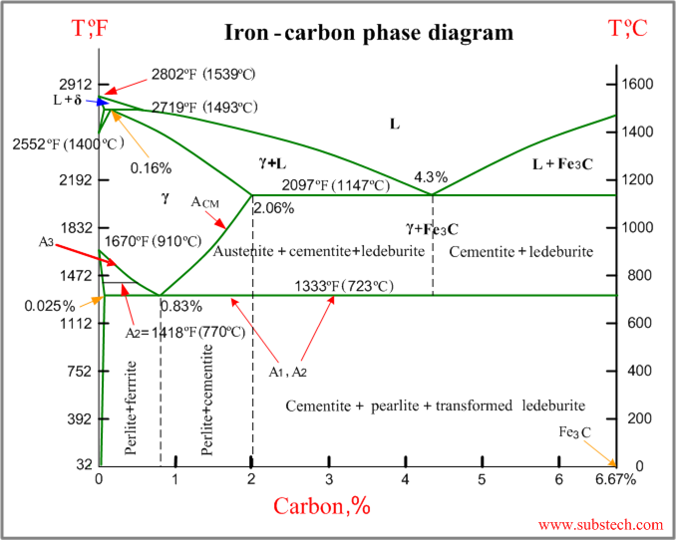

The following phases are involved in the transformation, occurring with iron-carbon alloys:
- L - Liquid solution of carbon in iron;
- δ-ferrite – Solid solution of carbon in iron.
Maximum concentration of carbon in δ-ferrite is 0.09% at 2719 ºF (1493ºC) – temperature of the peritectic transformation.
The crystal structure of δ-ferrite is BCC (cubic body centered).
- Austenite – interstitial solid solution of carbon in γ-iron.
Austenite has FCC (cubic face centered) crystal structure, permitting high solubility of carbon – up to 2.06% at 2097 ºF (1147 ºC).
Austenite does not exist below 1333 ºF (723ºC) and maximum carbon concentration at this temperature is 0.83%.
- α-ferrite – solid solution of carbon in α-iron.
α-ferrite has BCC crystal structure and low solubility of carbon – up to 0.025% at 1333 ºF (723ºC).
α-ferrite exists at room temperature.
- Cementite – iron carbide, intermetallic compound, having fixed composition Fe₃C.
Cementite is a hard and brittle substance, influencing on the properties of steels and cast irons.
The following phase transformations occur with iron-carbon alloys:
Alloys, containing up to 0.51% of carbon, start solidification with formation of crystals of δ-ferrite. Carbon content in δ-ferrite increases up to 0.09% in course solidification, and at 2719 ºF (1493ºC) remaining liquid phase and δ-ferrite perform peritectic transformation, resulting in formation of austenite.
Alloys, containing carbon more than 0.51%, but less than 2.06%, form primary austenite crystals in the beginning of solidification and when the temperature reaches the curve ACM primary cementite stars to form.
Iron-carbon alloys, containing up to 2.06% of carbon, are called steels.
Alloys, containing from 2.06 to 6.67% of carbon, experience eutectic transformation at 2097 ºF (1147 ºC). The eutectic concentration of carbon is 4.3%.
In practice only hypoeutectic alloys are used. These alloys (carbon content from 2.06% to 4.3%) are called cast irons. When temperature of an alloy from this range reaches 2097 ºF (1147 ºC), it contains primary austenite crystals and some amount of the liquid phase. The latter decomposes by eutectic mechanism to a fine mixture of austenite and cementite, called ledeburite.
All iron-carbon alloys (steels and cast irons) experience eutectoid transformation at 1333 ºF (723ºC). The eutectoid concentration of carbon is 0.83%.
When the temperature of an alloy reaches 1333 ºF (733ºC), austenite transforms to pearlite (fine ferrite-cementite structure, forming as a result of decomposition of austenite at slow cooling conditions).

Critical temperatures
- Upper critical temperature (point) A₃ is the temperature, below which ferrite starts to form as a result of ejection from austenite in the hypoeutectoid alloys.
- Upper critical temperature (point) A_{CM} is the temperature, below which cementite starts to form as a result of ejection from austenite in the hypereutectoid alloys.
- Lower critical temperature (point) A₁ is the temperature of the austenite-to-pearlite eutectoid transformation. Below this temperature austenite does not exist.
- Magnetic transformation temperature A₂ is the temperature below which α-ferrite is ferromagnetic.

Phase compositions of the iron-carbon alloys at room temperature
- Hypoeutectoid steels (carbon content from 0 to 0.83%) consist of primary (proeutectoid) ferrite (according to the curve A3) and pearlite.
- Eutectoid steel (carbon content 0.83%) entirely consists of pearlite.
- Hypereutectoid steels (carbon content from 0.83 to 2.06%) consist of primary (proeutectoid)cementite (according to the curve A_{CM}) and pearlite.
- Cast irons (carbon content from 2.06% to 4.3%) consist of proeutectoid cementite C₂ ejected from austenite according to the curve A_{CM} , pearlite and transformed ledeburite (ledeburite in which austenite transformed to pearlite).

Q3b) Some of the micro constituents of Iron and Steel are Austenite, Ferrite, Cementide, Pearlite, Bainite, Martenite, Troostite, Sorbite and Ledeburite.
Austenite (γ-iron): It is solid solution of ferrite iron carbide in gamma iron which is formed when steel contains carbon up to 1.8% at 1130°C. On cooling below 723°C it starts transforming into pearlite and ferrite. Austenite is non-magnetic and soft. It exists in FCC crystal structure.
Ferrite: It is a BCC iron phase with very limited solubility of carbon. The solubility of carbon in ferrite is 0.08% at 723°C. Ferrite does not harden when cooled rapidly. It is very soft and highly magnetic. At room temperature ferrite contains maximum 0.0025% C only.
Cementide: Cementide is actually Fe3C, which contains 6.67%C by weight, which is extremely hard and brittle in nature. Cementide increases gradually with increase in carbon percentage. it is magnetic at below 200°C. Cementide contains orthorhombic crystal structure.
Pearlite: Pearlite is a combination of ferrite and 13% of Cementide. Steel with 0.8% carbon is wholly Pearlite, less than 0.8% carbon is wholly Pearlite, less than 0.8% is hypo eutectoid contains ferrite and Pearlite and is soft. More than 0.8% is hyper eutectoid steel which contains Pearlite and Cementide which is hard and brittle. It is having a pearl like lusture when viewed through microscope.
Bainite: Bainite is the product of isothermal decomposition of Austenite and it cannot be produced by continuous cooling Banite is aggregated of ferrite and carbide. Also it is tougher.
Martenite: This is obtained by rapid cooling of Austenite. It is extremely hard and posses articular needle like structure. It is magnetic and has carbon content up to 2%. It is extremely hard and brittle. The decomposition of Austenite below 320°C starts the formation of Martensite.
Troostite: Troostite differs from Pearlite only in the degree of fitness of structure and carbon content. It is produced by transformation of tempered Martensite. Troosite is weaker than Martensite.
Sorbite: Sorbite micro structure constitute a mixture of ferrite and finely divided cementide produced on tempering martensite above 450°C. Pearlite, Troostite and Sorbite all are ferrite cementide mixture having a lamellar structure.
Ledeburite: Ledeburite is the product of eutectic reaction. Thus Ledebruite is a euctectic mixture; consists of alternative layers of Austenite and Cementide. It contains 4.3% carbon and is formed at about 1130°C.

